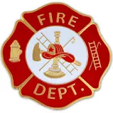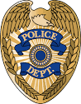

911 REFLECTIVE ADDRESS SIGNS
HIGHLY VISIBLE DAY OR NIGHT, REFLECTIVE MATERIAL BOTH SIDES
FADE RESISTENT, LASTS FOR YEARS

ORDER YOUR REFLECTIVE SIGN TODAY!
IT MAY SAVE YOUR LIFE OR SOMEONE YOU LOVE!
IF WE CAN’T FIND YOU! WE CAN’T HELP YOU!

ADDRESS NUMBER REQUESTED _____ _____ _____ _____ _____
NOTE: IF YOUR ADDRESS HAS FEWER THAN 5 DIGITS, PLEASE X OUT BOXES NOT USED.
MOUNTING PREFERENCE: HORIZONTAL ______ VERTICAL ______
SIGN ONLY $20.00 ______ SIGN WITH POST $25.00 ______
NAME ____________________________________________________
ADDRESS _________________________________________________
_________________________________________________
PHONE NUMBER __________________________________________

PLEASE MAKE CHECK PAYABLE TO: LICKING RURAL FIRE DEPARTMENT
Send Check With Order Form To: ERNIE BRILHART
13723 HWY AT
LICKING, MO 65542
AMOUNT PAID $ ________________ CHECK NUMBER ________________

